Section I: Scenario Demographics

Scenario Title: | Serotonin Syndrome
Date of Development: | (19/02/2016)
Target Learning Group: | Juniors (PGY 1 – 2) Seniors (PGY ≥ 3) All Groups

Section II: Scenario Developers

Scenario Developer(s): | Donika Orlich
Affiliations/Institution(s): | McMaster University
Contact E-mail (optional): | Donika.orlich@medportal.ca

Section III: Curriculum Integration

Learning Goals & Objectives
Educational Goal: | Expose learners to a hyperthermic, altered patient with serotonin syndrome.
CRM Objectives: | - Demonstrates problem solving through prompt ABC assessment and implementation of concurrent management approach  - Demonstrates situational awareness by avoiding fixation error and reassessing the situation as the case progresses
Medical Objectives: | - Initiates broad initial workup for the febrile altered patient  - Recognizes the serotonergic toxidrome and initiates rapid cooling and medical therapy  - Employs a tailored approach to ventricular dysrhythmia in the patient with serotonin syndrome

Case Summary: Brief Summary of Case Progression and Major Events
A 27-year-old female presents hot and altered to the ED with EMS. Likely cause is serotonin syndrome, precipitated by being on citalopram and methadone in the setting of a recent cocaine binge (all increase serotonin levels). She will develop Torsades de Pointes as a complication which must be treated with MgSO4. She will become increasingly agitated and febrile, requiring IV benzodiazepines, active cooling, and consideration of intubation with paralysis to achieve normothermia.

References
Marx, J. A., Hockberger, R. S., Walls, R. M., & Adams, J. (2013). Rosen's emergency medicine: Concepts and clinical practice. St. Louis: Mosby.
Buckley NA, Dawson AH, Isbister GK. Serotonin syndrome. BMJ. 2014 Feb 19;348:g1626
Isbister GK, Buckley NA, Whyte IM. Serotonin toxicity: a practical approach to diagnosis and treatment. Medical Journal of Australia. 2007 Sep 17;187(6):361.

Section IV: Scenario Script

A. Scenario Cast & Realism
Patient: | Computerized Mannequin |  |  |  |  | Realism:  Select most important dimension(s) |  |  | Conceptual
 | Mannequin |  |  |  |  |  |  |  | Physical
 | Standardized Patient |  |  |  |  |  |  |  | Emotional/Experiential
 | Hybrid |  |  |  |  |  |  |  | Other:
 | Task Trainer |  |  |  |  |  |  |  | N/A
Confederates | Brief Description of Role
Boyfriend | Provides collateral history. Patient has been on an antidepressant for some time. This past weekend she was well, though they did “party a lot and get pretty wasted last night”. If probed, he will admit to cocaine use.
B. Required Monitors
EKG Leads/Wires |  |  | Temperature Probe |  |  |  | Central Venous Line
NIBP Cuff |  |  | Defibrillator Pads |  |  |  | Capnography
Pulse Oximeter |  |  | Arterial Line |  |  |  | Other:
C. Required Equipment
Gloves |  |  | Nasal Prongs |  |  |  | Scalpel
Stethoscope |  |  | Venturi Mask |  |  |  | Tube Thoracostomy Kit
Defibrillator |  |  | Non-Rebreather Mask |  |  |  | Cricothyroidotomy Kit
IV Bags/Lines |  |  | Bag Valve Mask |  |  |  | Thoracotomy Kit
IV Push Medications |  |  | Laryngoscope |  |  |  | Central Line Kit
PO Tabs |  |  | Video Assisted Laryngoscope |  |  |  | Arterial Line Kit
Blood Products |  |  | ET Tubes |  |  |  | Other: Fans
Intraosseous Set-up |  |  | LMA |  |  |  | Other:
D. Moulage
Female wig. Diaphoresis.

E. Approximate Timing
Set-Up: |  | 10 min |  | Scenario: | 15 min |  |  | Debriefing: |  | 30 min

Section V: Patient Data and Baseline State

A. Clinical Vignette: To Read Aloud at Beginning of Case
A 27-year-old female was found by her boyfriend this morning seeming confused and warm. He called EMS. She has a history of opioid abuse and is on methadone, but he swears that she has takes this as prescribed and has not done any prescription pain meds lately. They did “party a lot yesterday”, but she was otherwise well, with no complaints of fever before today. With EMS the patient was noted to be diaphoretic, febrile and quite agitated. She has been placed in a resuscitation bay.
B. Patient Profile and History
Patient Name: Sandy Jones |  |  |  |  |  | Age: 27 |  |  |  |  |  |  |  | Weight: 60kg
Gender: M F |  |  |  |  |  | Code Status: Full
Chief Complaint: Fever and Altered LOC
History of Presenting Illness: As above
Past Medical History: |  | Depression |  |  |  |  | Medications: |  |  |  |  | Citalopram 40mg daily
 |  | Opioid Abuse |  |  |  |  |  |  |  |  |  | Methadone
Allergies: Penicillin
Social History: Binge EtOH on weekends, 1ppd smoker, + cocaine over weekend at a party
Family History: Unknown
Review of Systems: |  | CNS: |  |  | Confused this morning per boyfriend. Not oriented with EMS
 |  | HEENT: |  |  | No history of head injury/ recent trauma
 |  | CVS: |  |  | Nil
 |  | RESP: |  |  | No recent cough.
 |  | GI: |  |  | No recent abdo pain, vomiting, or diarrhea
 |  | GU: |  |  | No dysuria or recent urinary symptoms
 |  | MSK: |  |  | Nil |  |  |  |  |  |  |  | INT: |  | Nil
C. Baseline Simulator State and Physical Exam
No Monitor Display |  |  |  | Monitor On, no data displayed |  |  |  |  |  |  | Monitor on Standard Display
HR: 110 /min |  |  | BP: 122/75 |  |  |  |  | RR: 18/min |  |  |  |  |  |  | O₂SAT: 99%
Rhythm: NSR |  |  | T: 39.4ºC |  |  |  |  | Glucose: 6.4mmol/L |  |  |  |  |  |  | GCS: 14 (E4 V4 M6)
General Status: Shivering, diaphoretic
CNS: | Not oriented. Agitated. Seems “jumpy”
HEENT: | No signs HI. Pupils 4mm reactive bilaterally
CVS: | Normal
RESP: | Normal
ABDO: | Normal
GU: | Normal
MSK: | Inducible clonus, hyper-reflexia |  |  |  |  |  |  |  | SKIN: | Sweaty

Section VI: Scenario Progression

Scenario States, Modifiers and Triggers
Patient State | Patient Status | Learner Actions, Modifiers & Triggers to Move to Next State
1. Baseline State  Rhythm: Wide QRS  HR: 110/min  BP: 120/80  RR: 18/min  O₂SAT: 99%  T: 39.5ºC | GCS 14 as above. ++ agitated  Inducible clonus + hyper-reflexia | Learner Actions  - IV, O2, monitors  - Blood work (tox + sepsis + TSH + CK)  - Cap glucose  - ECG (wide QRS)  - NaHCO3 for wide QRS  - IV NS 1L bolus  - Consider antipyretic  - Broad-spectrum antibiotics  - Urine dip, βHCG  - ± Portable CXR  - Consider head CT | Modifiers  Changes to patient condition based on learner action  - Antipyretic no effect  - 1L IV NS HR 105, BP 125/85  - 1amp NaHCO3 narrowing of QRS (ECG with prolonged QT)  Triggers  For progression to next state  - All actions complete or 5 minutes 2. Torsades
2. Torsades  Rhythm: torsades  HR: 180/min  BP: 60/30  RR: 18/min  O₂SAT: 93%  T: 40.5ºC | Patient GSS drops to 8 (moaning) | Learner Actions  - Cardioversion at 100-200J  - MgSO4 2g IV  - Repeat ECG | Modifiers  - Cardioversion before MgSO4 brief NSR then back to torsades  Triggers  - MgSO4 given 4. More Agitated  - No MgSO4 by 3 min 3. Arrest
3. Arrest  Rhythm: torsades  HR: 180/min  BP: 0/0  RR: 0  O2- ??? | Patient loses pulse | Learner Actions  - IV MgSO4  - Defibrillation at 200J  - High quality CPR | Modifiers  - Defibrillation only No ROSC  Triggers  - MgSO4 given 4. More Agitated
4. More Agitated  Rhythm: NSR  HR: 120/min  BP: 140/90  RR: 16/min  O₂SAT: 99%  T: 40.5 | Patient GCS 13. Very jumpy. Speaking nonsense. | Learner Actions  - IV Benzos until more calm  - Active cooling  - Consider intubation for adequate sedation & cooling  - Call Poison Control | Modifiers  - 1st dose benzos HR 110  Triggers  - Cooling + benzos given  5. Labs Back  - 4 min 5. Labs Back
5. Labs Back  Rhythm: NSR  HR: 100/min  BP: 130/80  RR: 16/min  O₂SAT: 99% | Give lab results at beginning of state. | Learner Actions  - Consider cyproheptadine  - Continue active cooling  - ICU consult | END CASE PRN

Section VII: Supporting Documents, Laboratory Results, & Multimedia

Laboratory Results
Na: 138 | K: 4.5 |  |  | Cl: 102 |  | HCO₃: 22 |  | BUN: 6 |  | Cr: 70 |  |  | Glu: 6.8
VBG |  | pH: 7.28 |  |  | PCO₂: 30 |  | PO₂: 100 |  | HCO₃: 18 |  |  | Lactate: 3.4
TSH: 0.4 (normal) |  |  |  |  | CK: 100 (normal)
WBC: 14 |  |  | Hg: 122 |  |  |  | Hct: 0.4 |  |  |  | Plt: 300
ASA: <0.36 |  |  | Tylenol <0.15 |  |  |  | EtOH: <2 |  |  |  | Osm: 300 (OG=3)
Images (ECGs, CXRs, etc.)
CXR – normal  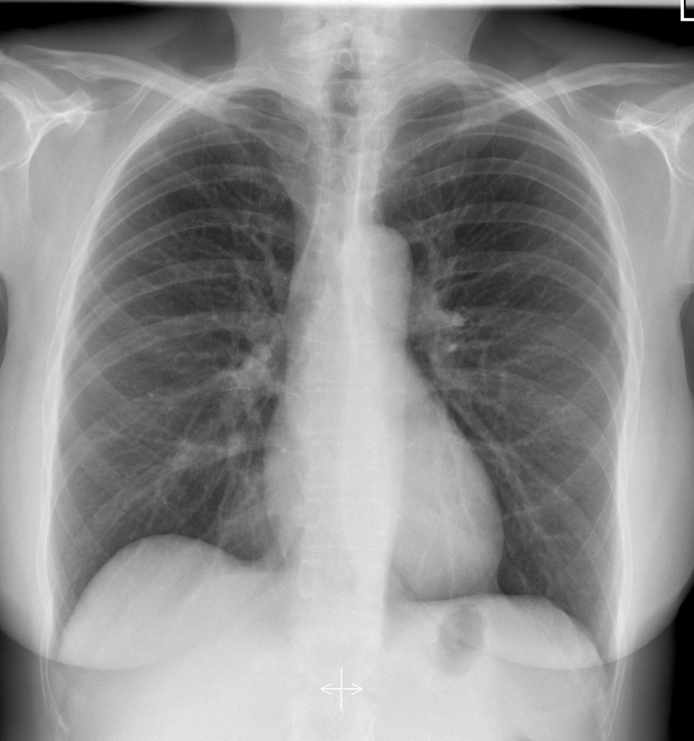  CXR source: https://radiopaedia.org/cases/normal-chest-radiograph-female-1 | Post-intubation CXR – normal  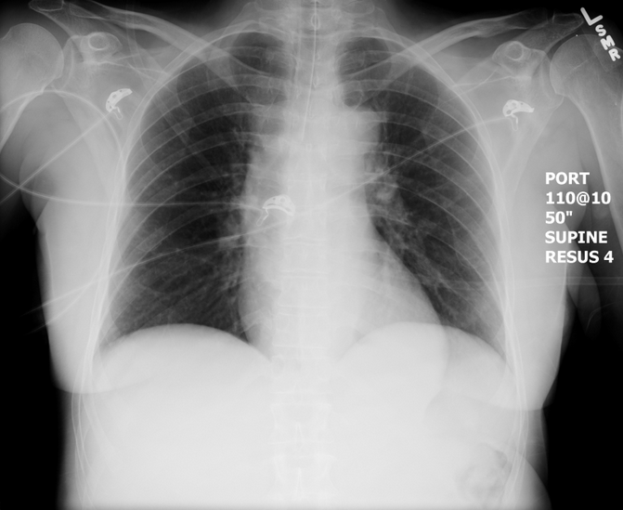  CXR source: https://emcow.files.wordpress.com/2012/11/normal-intubation2.jpg
1st ECG = prolonged QRS + QT  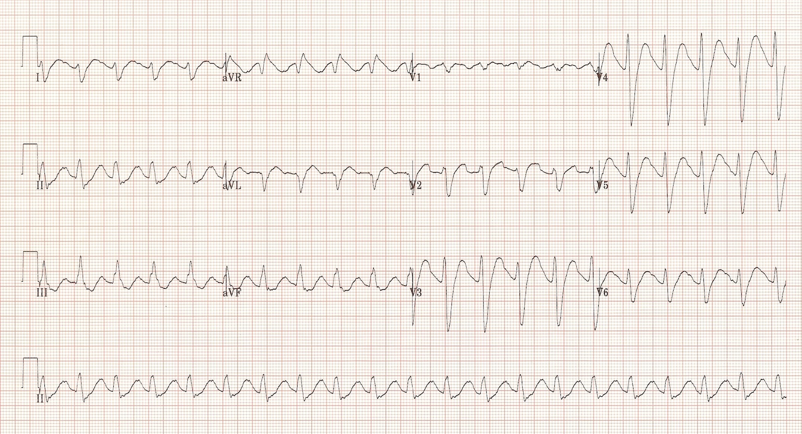  ECG source: https://lifeinthefastlane.com/ecg-library/basics/tca-overdose/ | ECG after NaHCO3 = prolonged QT  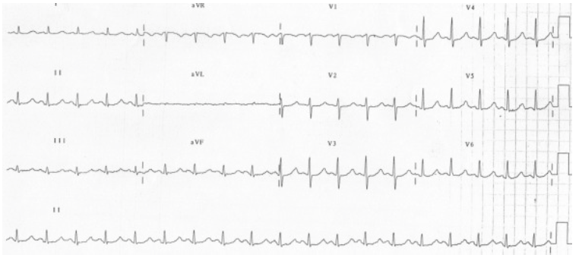  ECG source: https://lifeinthefastlane.com/ecg-library/basics/qt_interval/
3rd = Torsades
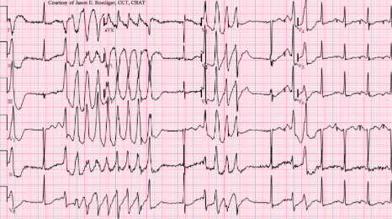
ECG source: https://en.wikipedia.org/wiki/Torsades_de_pointes

Section VIII: Debriefing Guide

General Debriefing Plan
Individual | Group |  | With Video | Without Video
Objectives
Educational Goal: |  | Expose learners to a febrile, altered patient with serotonin syndrome.
CRM Objectives: |  | - Demonstrates problem solving through prompt ABC assessment and implementation of concurrent management approach  - Demonstrates situational awareness by avoiding fixation error and reassessing the situation as the case progresses
Medical Objectives: |  | - Initiates broad initial workup for the febrile altered patient  - Recognizes the serotonergic toxidrome and initiates rapid cooling and medical therapy  - Employs a tailored approach to ventricular dysrhythmia in the patient with serotonin syndrome
Sample Questions for Debriefing
- What was your initial approach to the febrile altered patient?
- When did you consider serotonin syndrome as a possible diagnosis? What clued you in to this diagnosis?
- This patient did not take an overdose of her medications. Why might she have developed serotonin syndrome anyways?
- What are the main clinical features of serotonin syndrome?
- What is the main priority in the management of a patient with serotonin syndrome? What are some end-stage considerations for management?
- Why did the patient have a prolonged QRS? Was this part of the serotonin syndrome or related to something else? (Answer: cocaine-induced Na-channel toxicity)
Key Moments
- Identification of sick patient who is febrile and altered with initially broad work-up
- Recognition of serotonin syndrome and treatment of same with benzos and active cooling
- Recognition of torsades and appropriate, rapid treatment

